Lab 03 – Report
For setting up for this lab, I first downloaded msys64 from their downloads page. Once setup I added C:/msys64\ucrt64\bin to my system PATH variable.
I installed both C/C++ and CMake tools to my VSCode via the extension’s browser.
I opened a msys terminal and CD’d into the project folder. I ran the 3 CMake commands and observed 1 pass and 4 fails in the tests.
I then coded the necessary tests, one at a time, rerunning the cmake commands to verify the tests were passing.
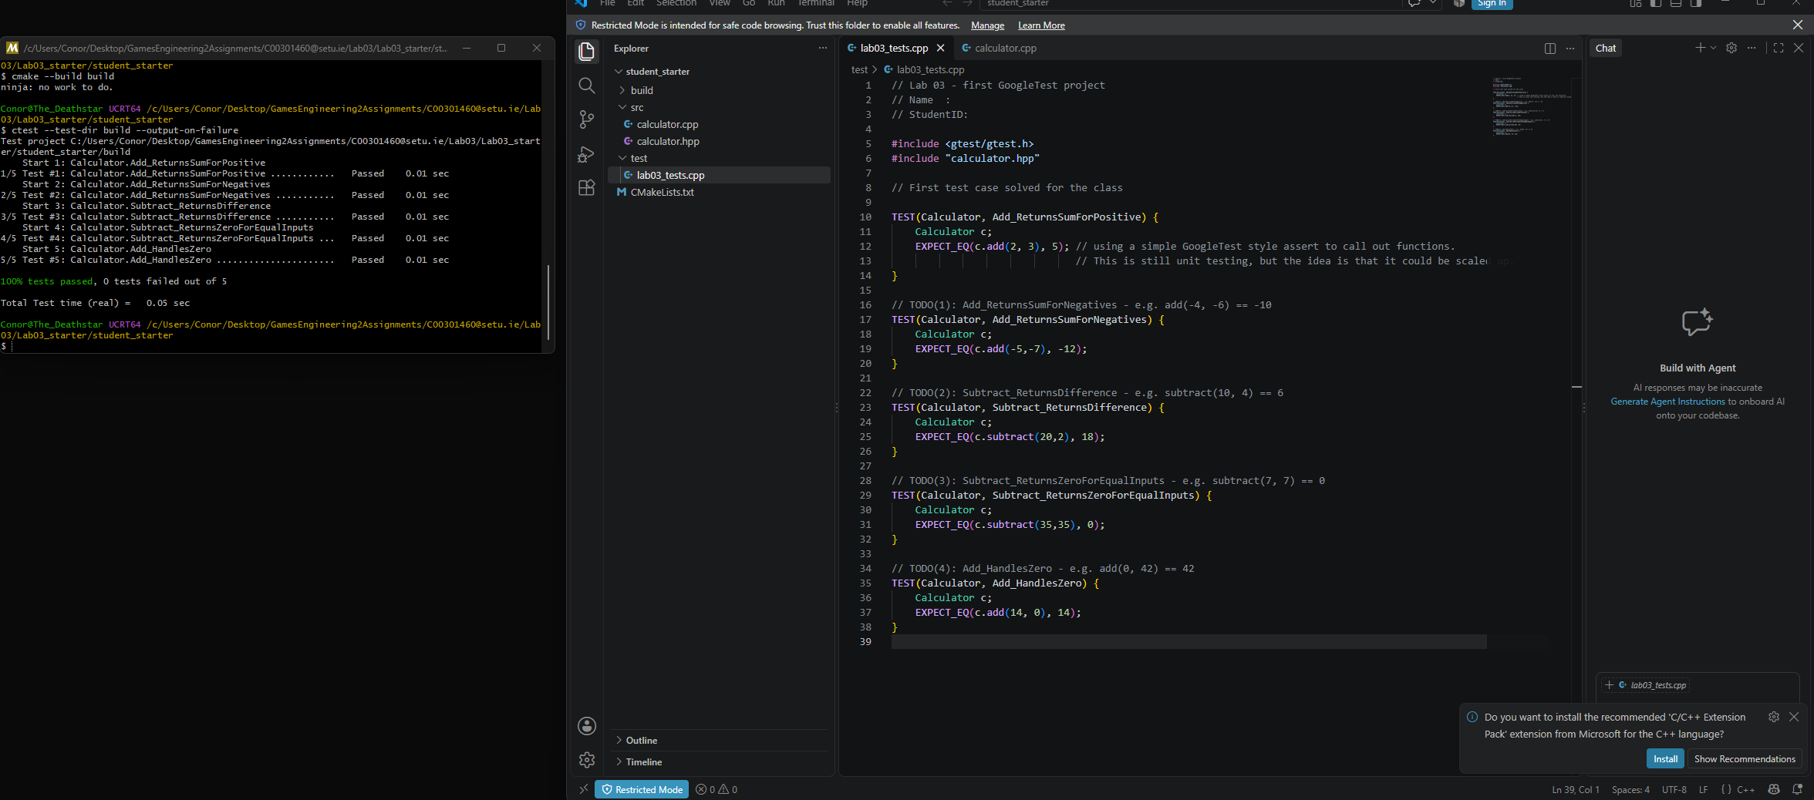

Working with a framework allows scalability as the tests are now automated instead of manually done one by one by a human engineer.

